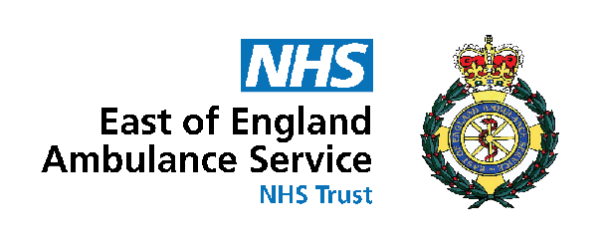



EEAST Monthly Update May 2021

Report Period: May 2021

Key Highlights


Sustainability Staff Surveys – During May, the sustainability team have published a short survey every week with each survey covering a different topic surrounding matters of sustainability.

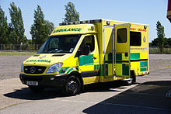
Our Fleet - Being an Ambulance Service, we know that our fleet makes up a significant proportion of our carbon emissions. In 2020 our fleet of ~700 vehicles travelled a total of 14.5 million miles using 3.5 million litres of fuel.


Hellesdon LED lighting project nearing completion - Our flagship LED lightbulb replacement scheme at our Hellesdon site is nearing completion. Due to Hellesdon being an AOC, the site is permanently staffed including at nights and weekends therefore the importance of switching to LED's was vital. It is estimated that the replacement of the old fluorescent lamps with LED replacements will reduce electricity consumption by 69%, providing substantial energy savings and modernising the site significantly.

Recycling Bin Rollout– Over 50% reductions in single-use small bin liners at Hellesdon as a result of the implementation of our new centralised recycling bins.

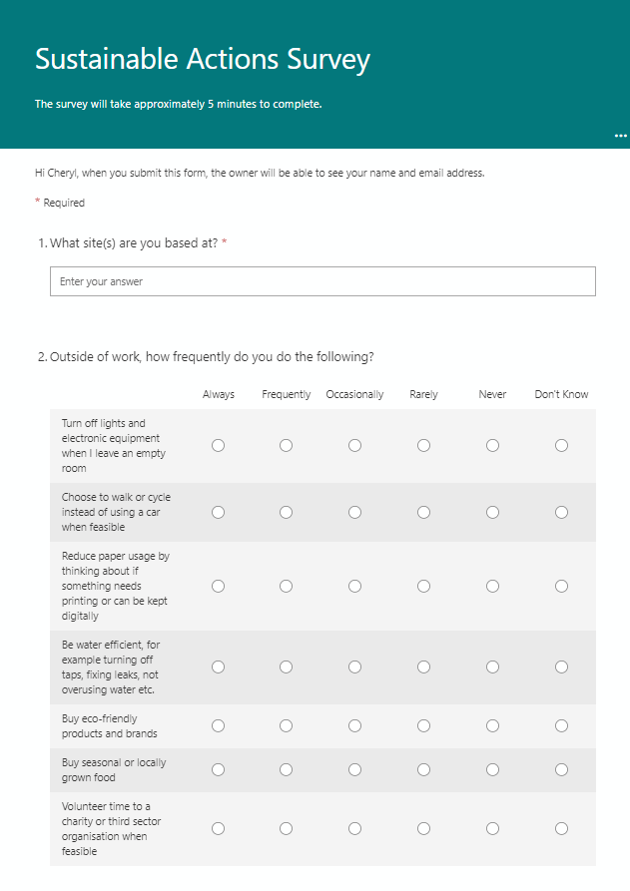
Sustainability Staff Surveys

During May, the sustainability team have published a short survey every week with each survey covering a different topic surrounding matters of sustainability. We know a lot of our staff already consider sustainability to be a really important topic, many of our colleagues are already green at home and have ideas about how this could translate in the workplace. The surveys are a great way of getting a clearer picture of staff habits and opinions and the results will help us to understand where we should be focusing future sustainability projects.

If you missed any of the surveys please find them below:

Commuting and Transport Survey

Sustainable Actions Survey

Waste and recycling survey

Electric Vehicles and Active Travel Survey

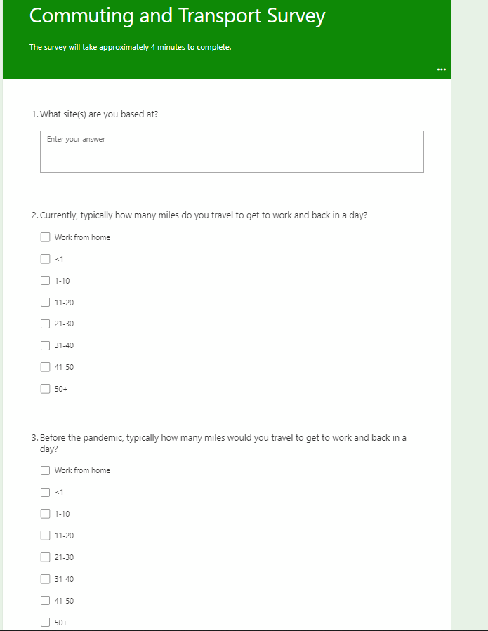


Recycling Bin Rollout

Our new centralised general waste and recycling bins have now been rolled out to all of our Make Ready sites with ~180 bins now in use in office, kitchen and communal areas replacing the individual general waste bins that have previously been used under individual desks. Our new bins aim to increase recycling rates across the trusts as currently only 28% of our waste goes into a recycling stream.

Having feedback from our Hellesdon site we can see that these bins are already beginning to have an impact on single-use bin liners. Having being implemented in March 2021, small individual waste bin liner usage have reduced by 51% in April compared to 2020 and 58% in May compared to 2020. These are great reductions for only being implemented in a short timespan. We hope that as the rollout expands even greater reductions in the use of single-use liners.

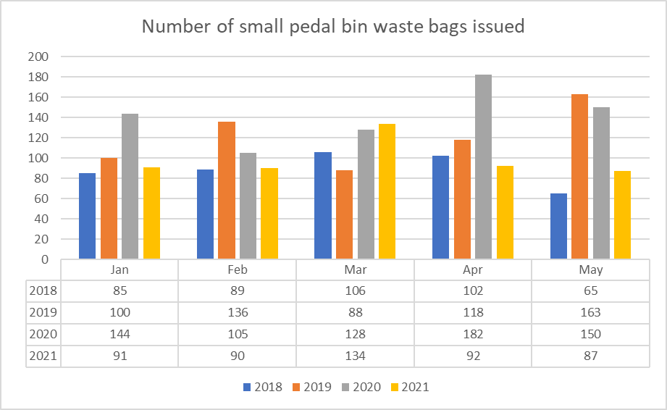
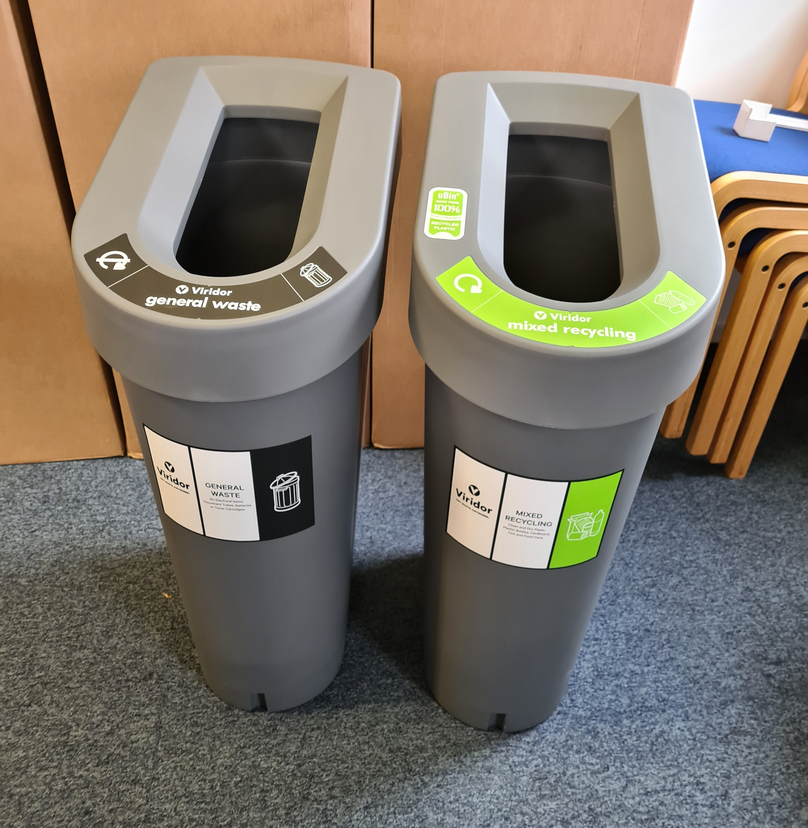
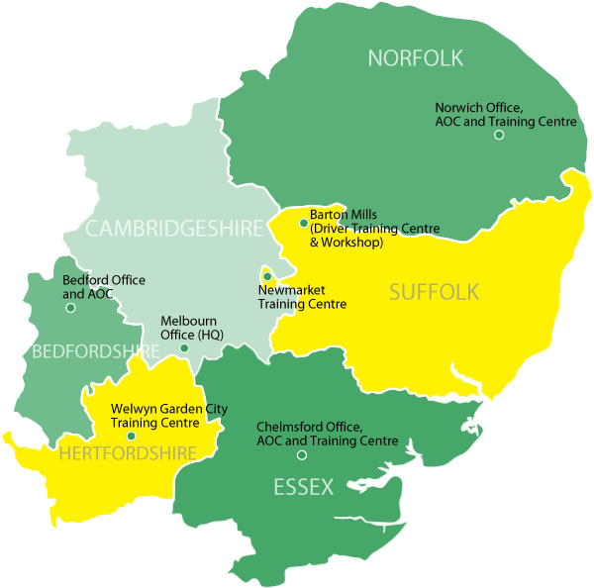
Our Fleet

Being an Ambulance Service, we know that our fleet makes up a significant proportion of our carbon emissions. In 2020 our fleet of ~700 vehicles travelled a total of 14,442,574 miles using 3,416,032 litres of fuel. While reducing our fleet consumption remains one of our biggest challenges due to the nature of our care services we are taking steps to ensure that our fleet is as streamlined and efficient as possible as well as switching to hybrid and electric support vehicles – including our all electric Clinical Engineering Vans!

So far, in 2021 on average our fleet travels a total of 1.4 million miles every month! This is the equivalent of 866,000kg of CO2 or flying in a Boeing 747 aircraft for 91 hours every month!

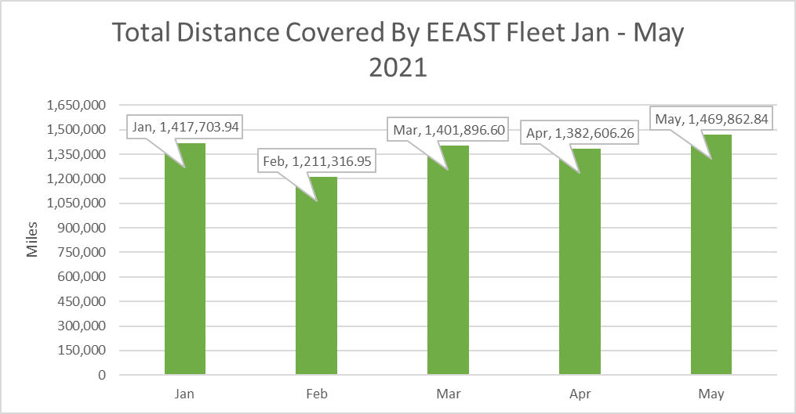

Month | Recycling Rates
December 2020 | 26%
January 2021 | 28%
February 2021 | 21%
March 2021 | 28%
April 2021 | 23%
May 2021 | 36%
Waste & Recycling

A major area of focus for the trust is to increase the amount of waste going into recycling streams (Cardboard, Metal, Mixed Municipal and Mixed Recyclate) to prevent large amounts of unnecessary waste going to Energy from Waste (EfW). In May, 36% of all waste generated by the Trust went into a recycling stream. This is a 13% increase from the previous month and the highest recycling rate the Trust has seen in the past 6 months. Through the continued implementation of several projects such as the rollout of recycling stations and communications and awareness programs we aim to increase recycling rates even further over the coming months.
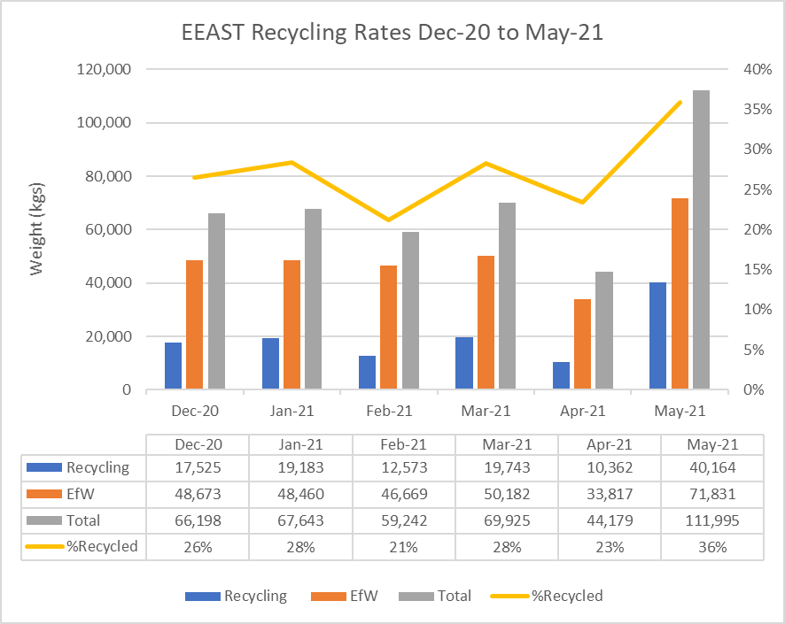

Clinical Waste

It is clear the impact of COVID-19 has had on the volume of clinical waste being
generated through our day-to-day operations. When comparing data between 2019/20 and 2020/21, in every month the Trust has generated more tonnes of clinical waste this year compared to the previous. However, April 2021 goes against this trend having a lower rate of collected tonnes than April 2020.

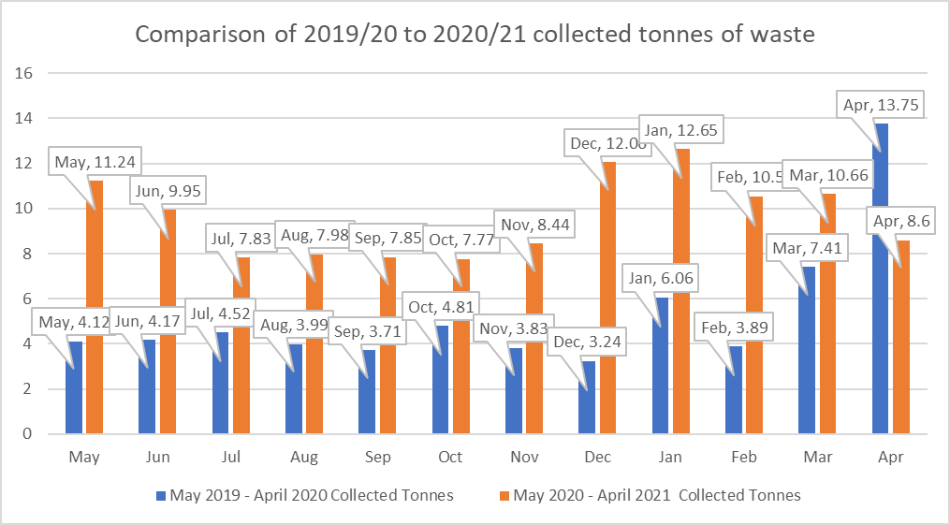

Upcoming Sustainability Dates – June

Why not get involved in some of the upcoming sustainability days?

Mon | Tues | Weds | Thurs | Fri | Sat | Sun
 | 1  30 Days Wild | 2 | 3 | 4 | 5  World Environment Day | 6
7 | 8  World Oceans Day | 9 | 10 | 11 | 12 | 13
14 | 15 | 16 | 17  Plastic Free Beauty Day | 18  Sustainable Gastronomy | 19  National Refill Day | 20
21 | 22 | 23 | 24 | 25 | 26 | 27
28 | 29 | 30 | 31

What do you think?

Let us know what you think of the latest EEAST monthly news update, or what you would like to see more of: sustainability@eastamb.nhs.uk

